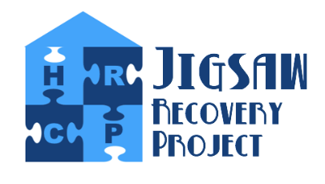
Jigsaw Recovery Project
108 Aidan House, Sunderland Road, Gateshead, NE8 3HU
Tel: 0191 4900589

APPLICATION FOR EMPLOYMENT
Post Applied For:
Title:
First Name:
Surname:
Home Address:
Post Code:
Telephone Numbers:
Home: | Work: | Mobile:
Email:

PREVIOUS EMPLOYMENT HISTORY
Starting with most recent employment first please detail below previous employment history. If there have been any gaps to employment you must detail as to why.
Date From | Date Too | Job Title | Brief outline of roles and responsibilities

QUALIFICATIONS & TRAINING RELEVANT TO THIS ROLE

WHY HAVE YOU APPLIED FOR THIS POSITION

EXPERIENCE AND SKILLS
EXPERIENCE:
SKILLS:
KNOWLEDGE:

Do you have a valid UK driving Licence & Access to transport | Yes | No

REFERENCES
Please supply details for 2 references. At least one should be previous employer where possible. If you are unable to supply 2 previous employers or at least 1 then you must advise as to why i.e. no previous employer due to full time education. Please then supply details for character references.
Name:  Position / Relationship:  Organisation / Home Address:  Email:  Contact Number: | Name:  Position / Relationship:  Organisation / Home Address:  Email:  Contact Number:

DECLARATION
I declare that the information contained within this application and Equality and Diversity monitoring form is correct. I understand that deliberately giving false information or incomplete information would disqualify me from the appointment, or if already appointed, make me liable for dismissal.
Signed: | Date:

